
Caron

Caron, Donna 555-3124
Caron, Phil 555-1476
Carul, Al 555-3255
Carull, John 555-6780
Carum, Dale 555-1188
Carun, Will 555-6245
Caruso, L 555-1342
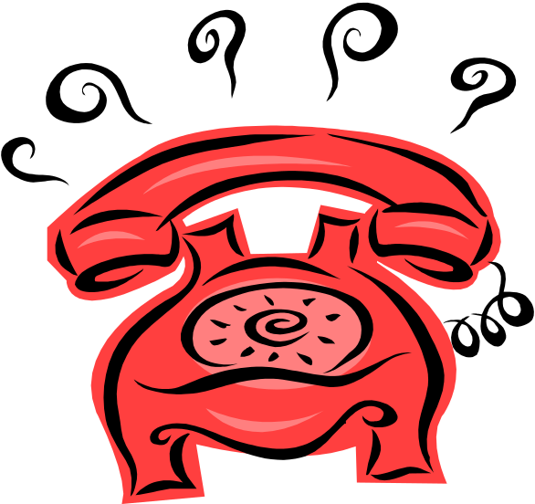
Ceraf, Betty 555-6771
Cerall, Gary 555-9910
Ceram, J 555-5728
Ceras, Cam 555-3187
Ceras, Jeyur 555-1489
Cesus, Cristh 555-7889
Cesusa, Brunch 555-1244
Charus, Great 555-4777
Chathus, Bethy 555-2489
Chathus, Smith 555-7811
Chatmuos, JR 555-8944
Chetta, Monkay 555-4268
Chetta, Trott 555-7811
Cleopatra, Walker 555-4421
Cleas, Taylor 555-7822
Clear, Hyland 555-1660
Clear, Schmidt 555-7442
Clear, Moore 555-1444

